**ASP.NET MVC Assignment**

**Assignment 4**

**Objective:** To work with Strongly-typed view in ASP.NET MVC project.

**Problem:**

**Task1:** Create an HTML page which contains two following hyperlinks:

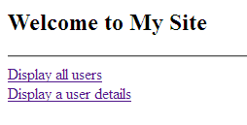

**Task2:** When **“Display all users”** is clicked, it should display all the user’s details stored in the “**Registrations**” collection in following format:

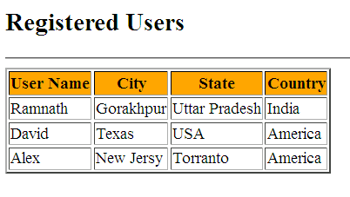

**Task3:** When the hyperlink “**Display a user details**” is clicked it should give a view page containing the input textbox for user name as below:

**Enter Username :**

**Display**

**Task4:** When **“Display”** button is clicked after selecting user name for e.g “**Ramnath**”, it should display the details of that user in another view as below:

|  |  |
| --- | --- |
| **User Details** | |
| Name | Ramnath |
| City | Gorakhpur |
| State | Uttar Pradesh |
| Country | India |